Neon Nights

User Instruction Manual

Andrew Miller

Austin Blair

Joseph Ghan

Table of Contents

Please note! 2

Installing SQL Server 2019 3

Installing Project Neon 5

Changing the Tax Rate 6

Creating a New Invoice 7

Customers Tab 8

Transactions Tab 10

Opening an Invoice 10

Voiding an Invoice 11

Printing an Invoice 12

# Please note!

SQL server and .NET framework must be installed prior to using this software!

* For SQL Server
  + Run “SQLServerExpress_2019.exe” before launching your software.
* For .NET Framework
  + Your software will take care of this requirement for you. Your Windows machine already comes prepackaged with the latest version of .NET Framework (ver. 4.x).
  + If you experience any issues with this, please contact your network administrator.

# Installing SQL Server 2019

1. Double click and run SQLServerExpress_2019.exe



1. Allow the application to make changes to the computer’s hard drive
2. On the “Select an Installation Type:” screen, select “Download Media” 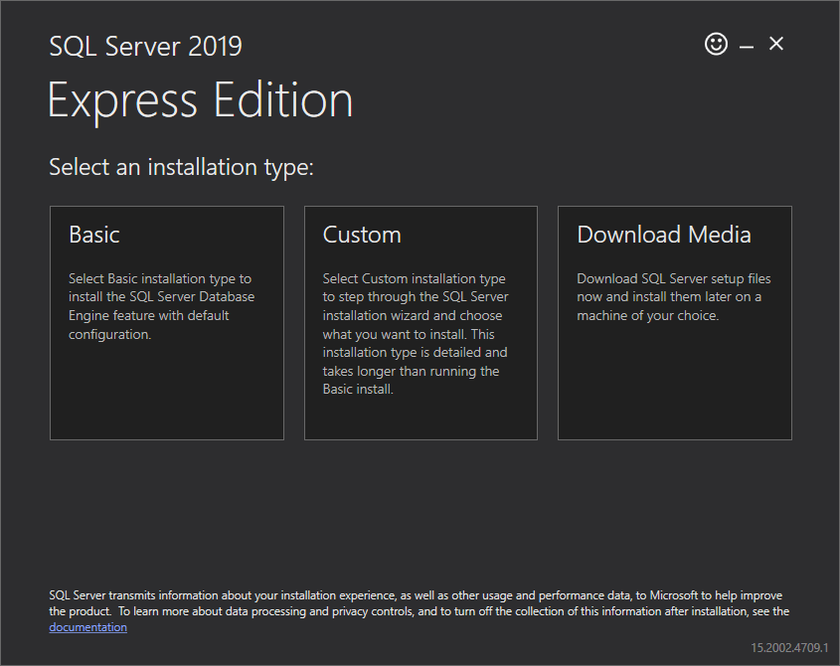
3. Select “LocalDB” and leave the default download location
   1. C:\Users\[your_user_name]\Downloads\en-US

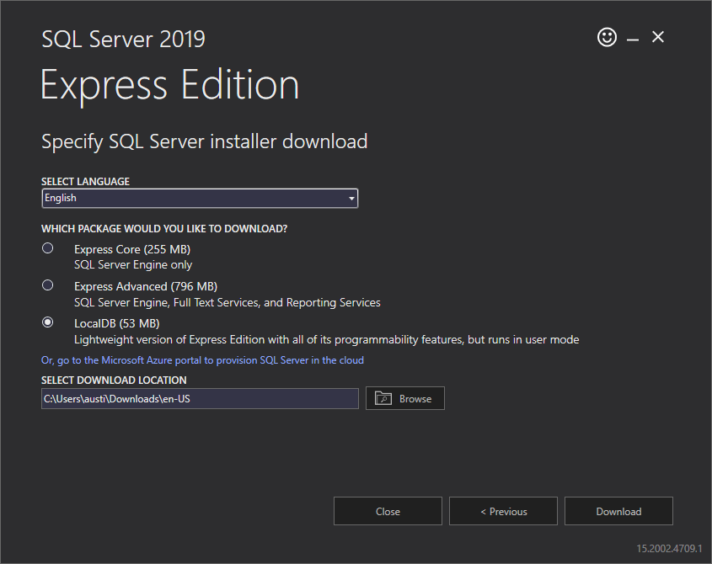

1. Navigate to Downloads\en-US and double click the SqlLocalDB.msi file



1. Follow the on-screen instructions to download LocalDB
   1. Make sure to allow it to make changes to the hard drive

You are done! LocalDB is now installed!

# Installing Project Neon

**Warning!**

SQL server express 2019 ***must*** be installed before Project Neon.

1. Extract everything from the ProjectNeon.zip folder
2. Double click the “ProjectNeon.exe” file
   1. If a security warning pops up, allow the application to run as is. You may need administrative rights to do so
3. (Optional) To create a short cut to access the program easier, right click the “ProjectNeon.exe” file and then click “Send to Desktop” 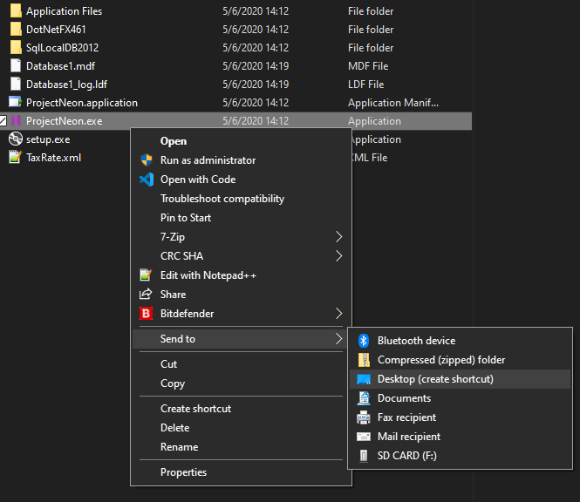

# Changing the Tax Rate

If the tax rate changes, then changing the tax rate will be required for an accurate invoice.

1. On the “Add invoice” tab, click the “settings” button at the bottomA screenshot of a social media post

   Description automatically generated
2. Change the tax rate amount in the dox and click “save.”

# Creating a New Invoice

1. To create a new invoice, make sure you are on the “Add Invoice” tab. It will look as follows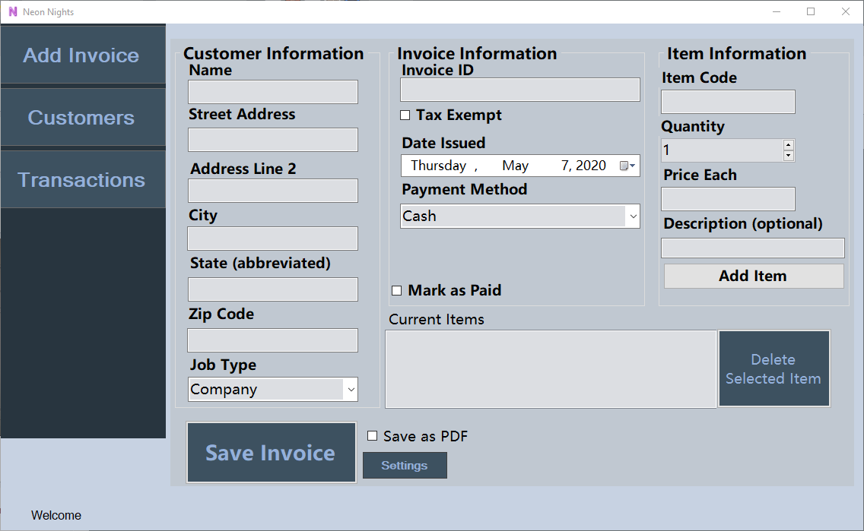
2. Fill out the information as follows. If using a check, a new box will appear asking for the check number.
3. Click “Save Invoice”
4. If you need to delete an item, click it in the “Current Items” section and click “Delete Selected Item”

# Customers Tab

The customers tab has information regarding customers that have been entered into the system via creating new invoices. It will display their name, address, city, state, and zip code. It will also show any outstanding debt they may have.

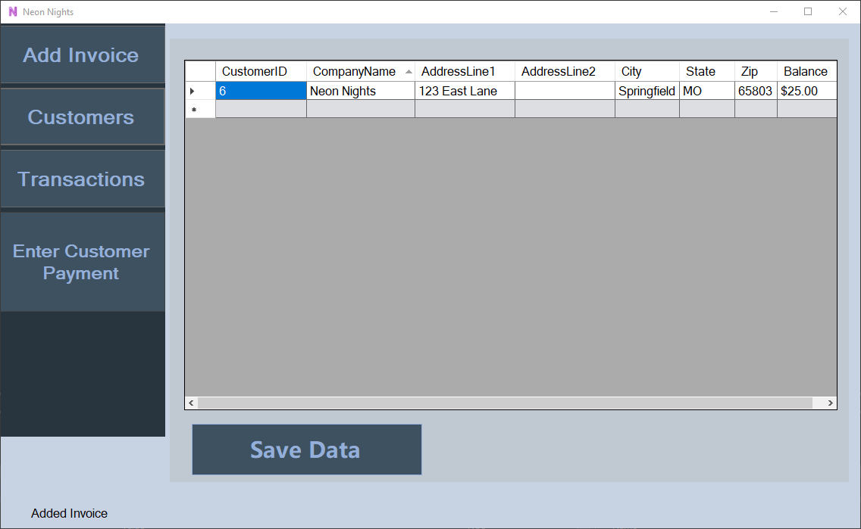

Entering customer payment:

1. Select the customer in the grid view and click “Enter Customer Payment”
2. Enter payment information into the customer payment window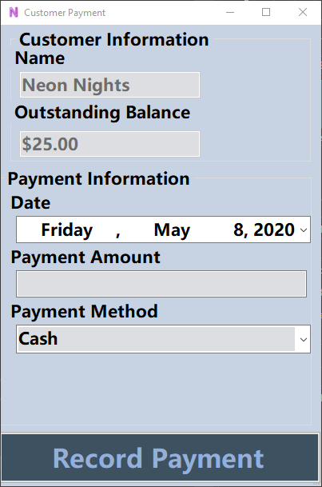
3. If paying with check, change payment method from “Cash” to “Check”
   1. A new box will appear asking for the check number
4. Click “record payment” when finished

# Transactions Tab

The transactions tab shows all invoices currently recorded into the system. It shows the company that owns the invoice, the invoice number, the date issued, its aging, and the total of the invoice. The balance section simply shows how much is remaining on the invoice before it is fully paid off.

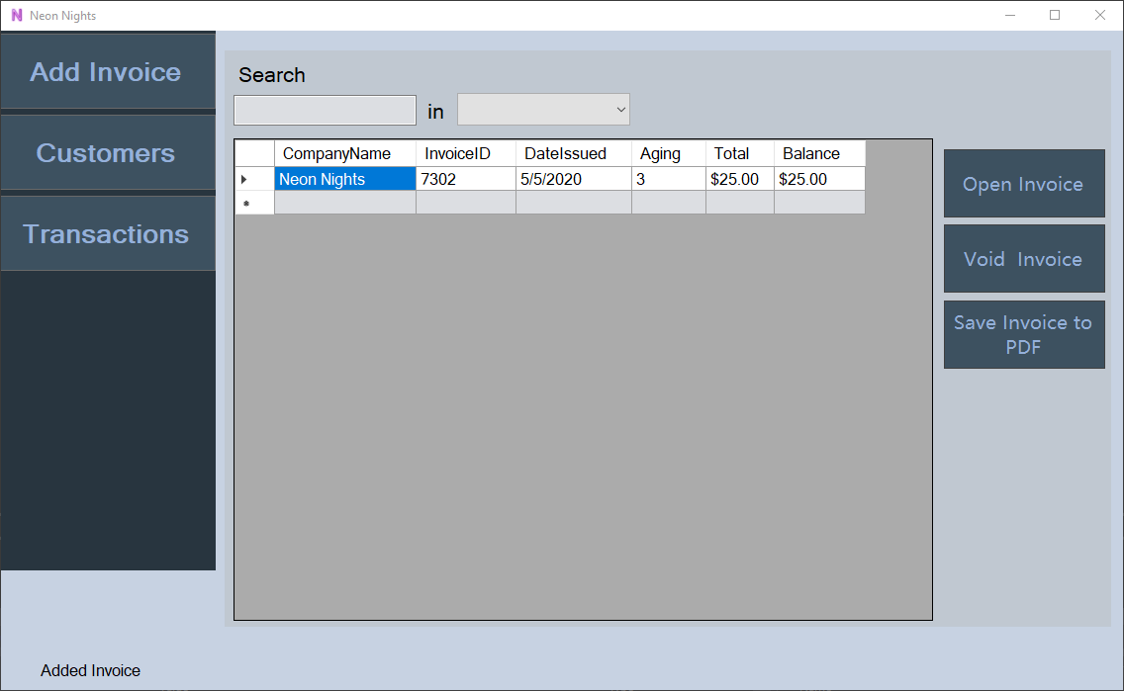

You have the option to open the invoice, which allows you to edit said invoice, void the invoice, or save the invoice as a PDF, which will allow you to print it at a later date.

# Opening an Invoice

1. Select an invoice by click in any section of the invoice you wish to open.
2. Click “open invoice” on the side
3. When the “Alter Invoice” screen appears, enter any information that needs to be changed. 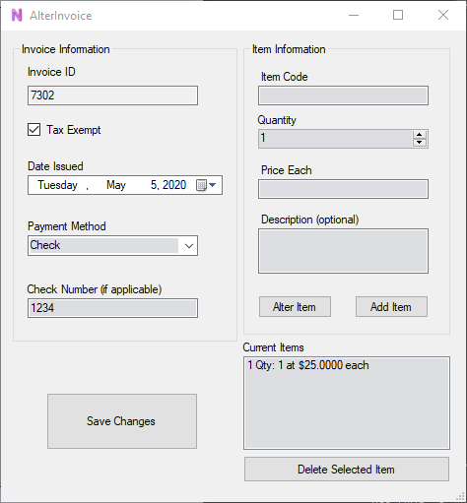
4. To add a new item, simply fill in the information and click “Add Item”
5. To alter an item, select the item in the “Current Items” section.
6. The information will appear in the boxes above. Change the information as needed and then click “Alter Item”
7. When you are finished, click “Save Changes”

# Voiding an Invoice

Voiding an invoice is simple. All you need to do is select the invoice in the panel and click “Void Invoice.” This will remove it from the system.

# Printing an Invoice

Printing an invoice is simple. All you need to do is select the invoice you wish to print and select “Save Invoice to PDF.” The invoice will appear in a separate screen showing you a preview of it.

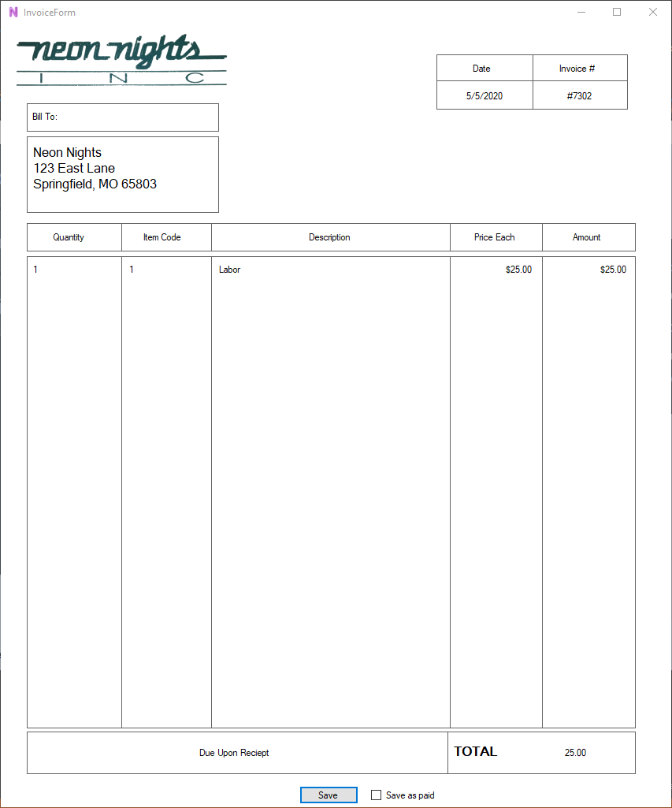

Clicking the “save” button pops up a print dialog screen. With this screen active, you can select which printer you want to print to. Alternatively, you can select “Print to PDF” to have the invoice be saved in PDF format for a later date.